Syeda Reeha Quasar

14114802719

3C7

Experiment - 7

Switching Theory and Logic Design (STLD)

Aim

To realize binary to gray and gray to binary code converter.

# **EXPERIMENT - 7**

## **AIM:**

To realize binary to gray and gray to binary code converter.

## **Hardware and Software Apparatus Required**

Hardware:

Breadboard, IC 7486 (XOR), LEDs, 5V power supply, connecting wires.

Software Simulation:

The schematic models of the desired circuits will be stimulated on MULTISIM (Free Software), easily accessible at [www.multisim.com](http://www.multisim.com).

Components used – Source (Clock Voltage), Passive elements (resistor), Digital components (AND, OR, NAND, NOR, XOR, XNOR, Inverter), Probe for Analysis and annotation (Digital), Schematic connectors (Ground)

## **Theory:**

The gray code is a non weighted code. The successive gray code differs in one bit position only that means it is a unit distance code. It is also referred as cyclic code. It is not suitable for arithmetic operations. It is the most popular of the unit distance codes. It is also a reflective code. An n-bit [Gray code](https://www.electrical4u.com/gray-code-binary-to-gray-code-and-that-to-binary-conversion/) can be obtained by reflecting an n-1 bit code about an axis after 2n-1 rows, and putting the MSB of 0 above the axis and the MSB of 1 below the axis. The below solved examples may useful to understand how to perform binary to gray and gray to binary code conversion. This conversion method strongly follows the EX-OR gate operation between binary bits.

**Method of Conversion**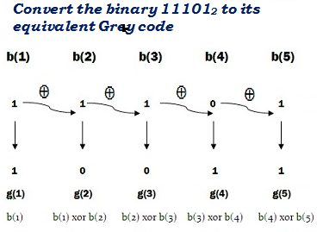

a)

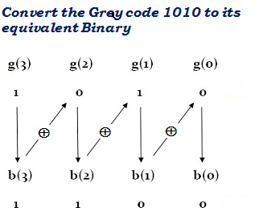

b)

Fig 13.1 a) Binary to gray b) Gray to Binary

**Logic Diagrams**

**a)**

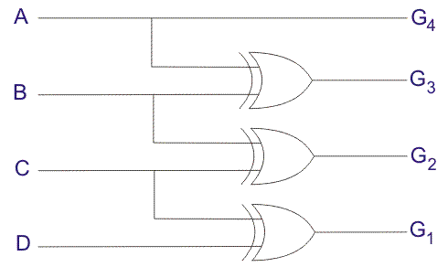

**b)**

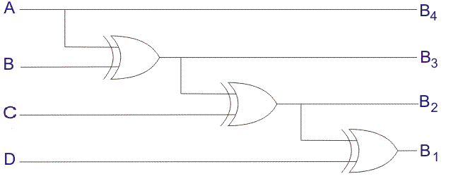

Fig 13.2 Logic Diagram of a) Binary to Gray b) Gray to Binary

#### **Binary to Gray Code Converter Table**

|  |  |  |
| --- | --- | --- |
| **Decimal Number** | **Binary Code** | **Gray Code** |
| 0 | 0000 | 0000 |
| 1 | 0001 | 0001 |
| 2 | 0010 | 0011 |
| 3 | 0011 | 0010 |
| 4 | 0100 | 0110 |
| 5 | 0101 | 0111 |
| 6 | 0110 | 0101 |
| 7 | 0111 | 0100 |
| 8 | 1000 | 1100 |
| 9 | 1001 | 1101 |
| 10 | 1010 | 1111 |
| 11 | 1011 | 1110 |
| 12 | 1100 | 1010 |
| 13 | 1101 | 1011 |
| 14 | 1110 | 1001 |
| 15 | 1111 | 1000 |

#### **Gray to Binary Code Converter Table**

|  |  |  |
| --- | --- | --- |
| **Decimal Number** | **Gray Code** | **Binary Code** |
| 0 | 0000 | 0000 |
| 1 | 0001 | 0001 |
| 2 | 0010 | 0010 |
| 3 | 0011 | 0011 |
| 4 | 0110 | 0100 |
| 5 | 0111 | 0101 |
| 6 | 0101 | 0110 |
| 7 | 0100 | 0111 |
| 8 | 1100 | 1000 |
| 9 | 1101 | 1001 |
| 10 | 1111 | 1010 |
| 11 | 1110 | 1011 |
| 12 | 1010 | 1100 |
| 13 | 1011 | 1101 |
| 14 | 1001 | 1110 |
| 15 | 1000 | 1111 |

## **Procedure followed on MULTISIM:**

1. Check all the components for their working.
2. Insert the appropriate IC into the IC base.
3. Make connections as shown in the circuit diagram.
4. Verify the results and observe the outputs.

## **PRECAUTIONS:**

1. All ICs should be checked before starting the experiment.
2. All the connection should be tight.
3. Always connect ground first and then the supply.
4. Switch off the power supply after completion of the experiment.

## **RESULT:**

Gray to binary and binary to Gray code converter has been studied and its truth table is verified.

**Circuits and Output waveform**

**Binary to Gray**

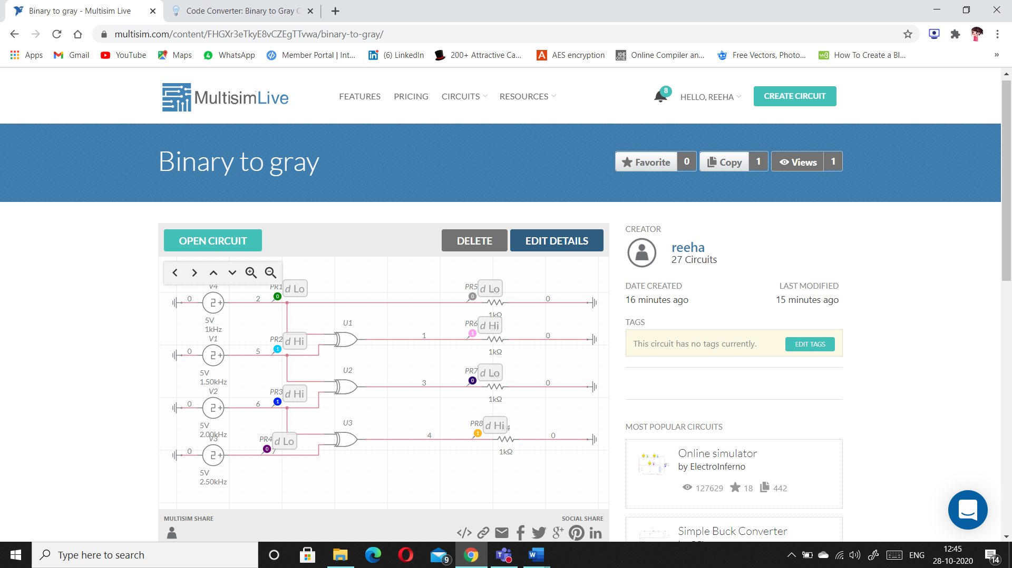

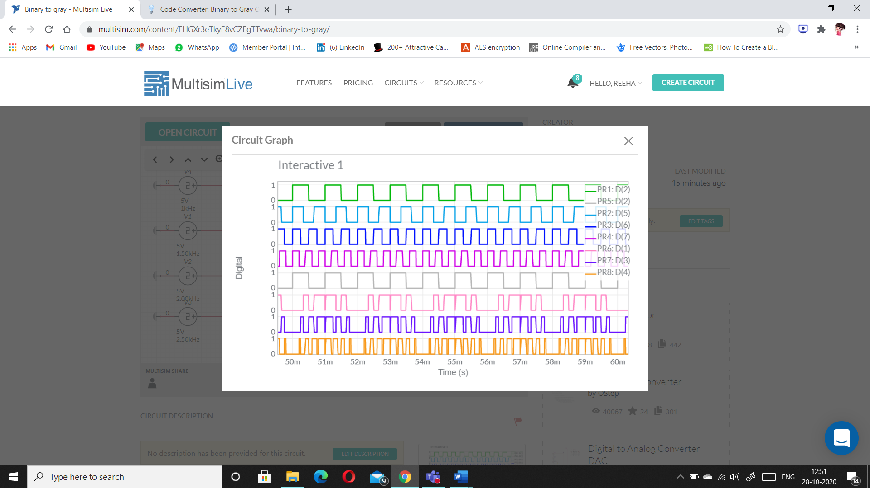

**Gray to Binary**

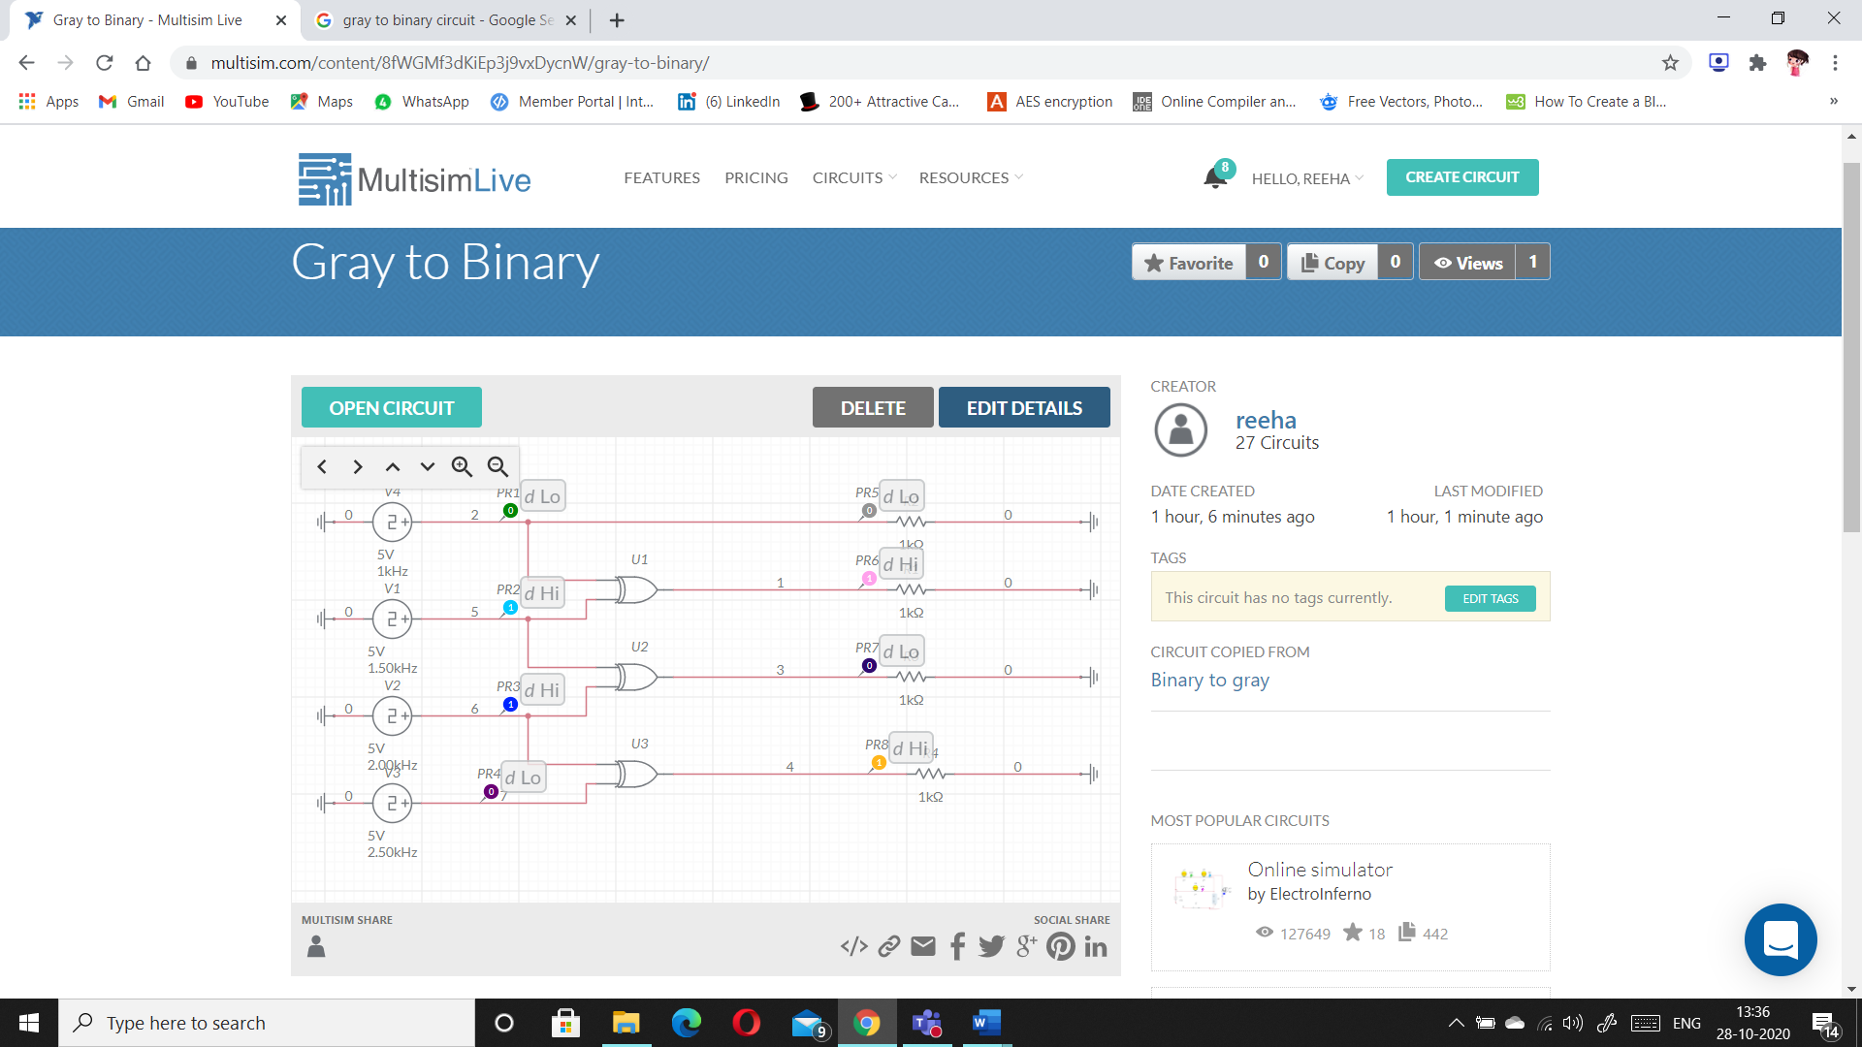

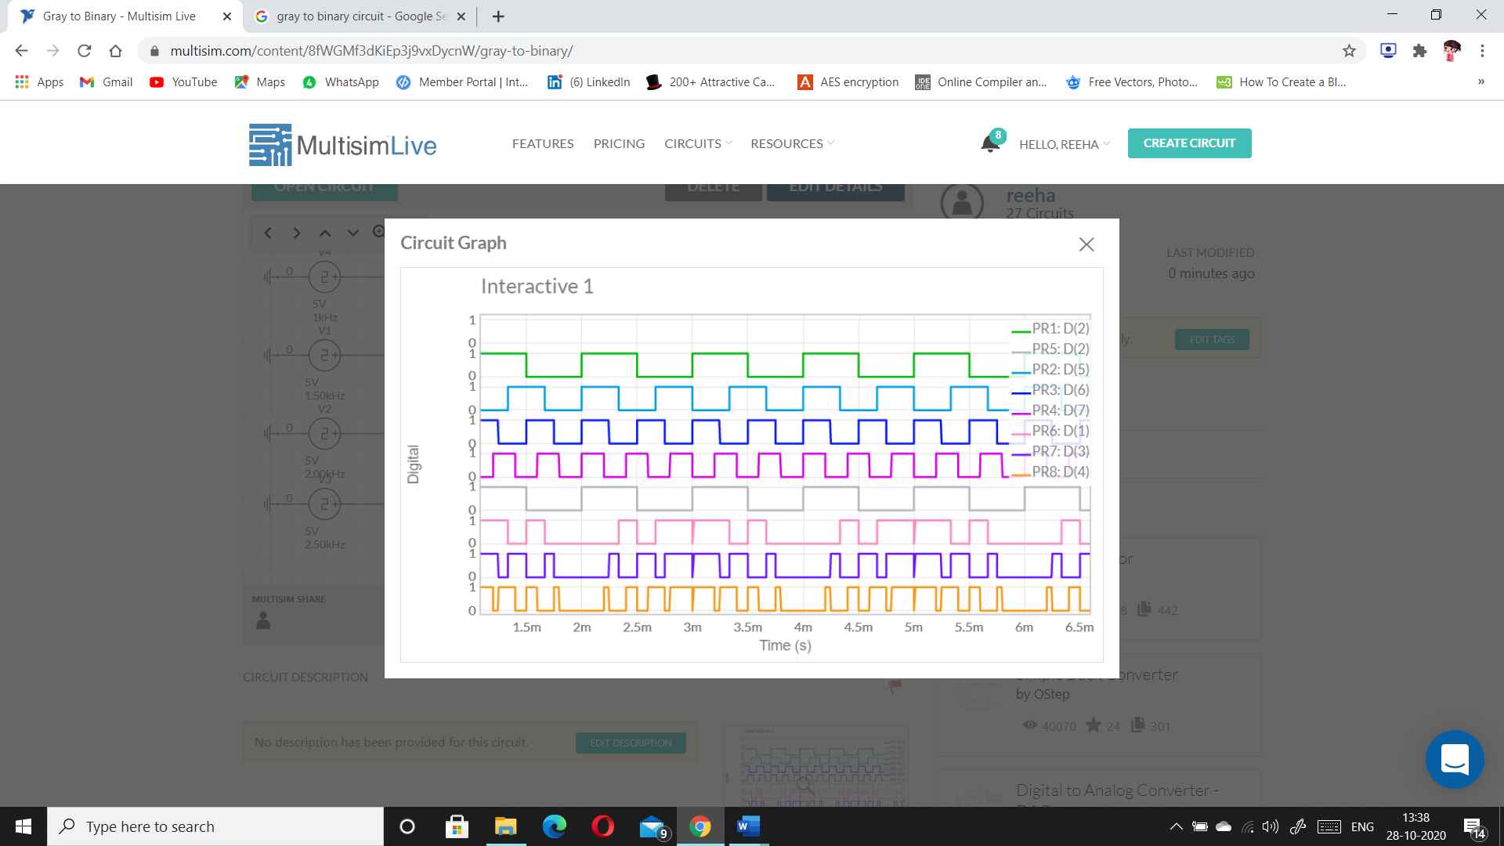

# **VIVA-VOCE QUESTIONS:**

1. **Why Gray code are called Unit Distance Code?**

Ans.

A unit distance code derives its name from the fact that there is only one bit change between two consecutive numbers. The excess 3 gray code is such a code, the values for zero and nine differ in only 1 bit, and so do all values for successive numbers.

1. **What are applications of Gray Codes?**

Ans.

Its used in in digital electronics. For example an adder. Practical applications can be thought of any condition which requires not more than one bit to switch at a time. Even in terms of devices when we think at a level which is at a threshold of device physics and digital vlsi; if a cmos gate switches which is a part of series of other gates; its fine.

1. **What are Reflected codes?**

Ans.

The reflected binary code or Gray code is an ordering of the binary numeral system such that two successive values differ in only one bit (binary digit).

1. **Why Gray Coding is used in K- mapping instead of binary?**

Ans.

Because Gray code only changes one bit at a time as you move between adjacent states, so it makes the groupings of terms possible, because they're next to each other. If you used binary code, the regions would be disjointed and the grouping of terms not obvious.